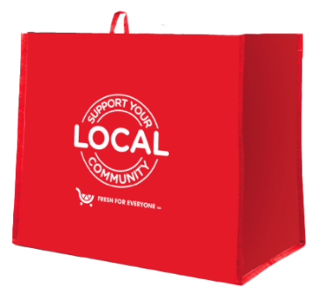

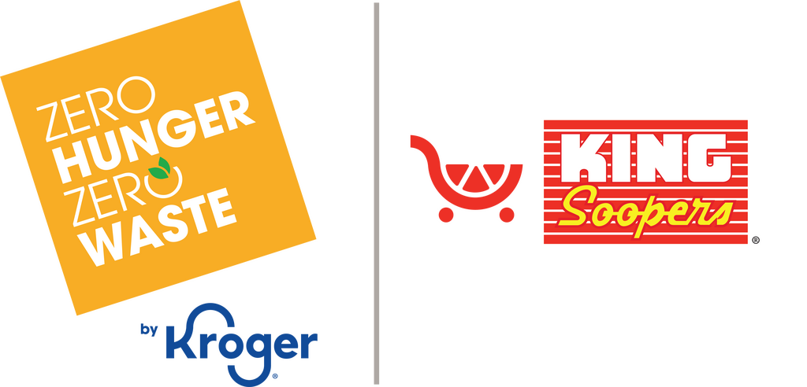

Month 2 Launch Email

SUBJECT LINE: Month two starts now; let’s make this month count even more!
PREVIEW TEXT: Every bag purchase continues to gives back.

Dear [Staff/Board/Volunteers/Supporters],

We’re excited to share that month two of our partnership with the King Soopers Fight Hunger
bag program starts today! We have another full month to grow our impact even further.
Throughout [month 2], every $2.50 reusable Fight Hunger bag purchased at the King Soopers
located at [address of selected store(s)] will continue to generate a $1 donation for
[name of organization].
This is where momentum matters most. The more we share, the more we can achieve together.
Please help us keep the energy going by spreading the word to your friends, family, and
community. A simple purchase can make a real difference, and every bag brings us one step
closer to helping those we serve.
Thank you for being part of this effort and for continuing to stand behind our mission.
With gratitude,
[Signature]

