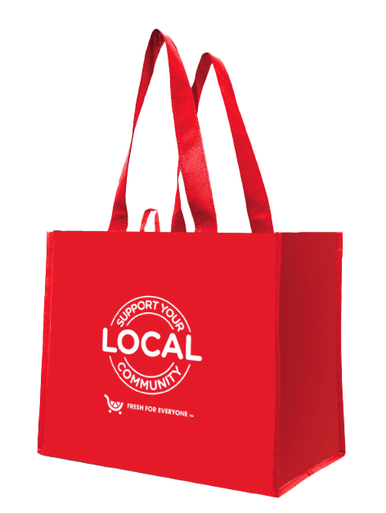


FIGHT HUNGER BAG PROGRAM

Reminder Email

SUBJECT: We have [insert number of weeks or other time frame] weeks remaining in the first month of our City Market Fight Hunger bag program partnership!
PREVIEW TEXT: There’s still time to maximize this opportunity for our cause!

Good morning,
We've reached [or We will shortly reach] the halfway point in the first month of our [insert months] partnership with the City Market Fight Hunger bag program. This is a wonderful opportunity to raise funds for our organization, spark positive change in our community, and help feed those in need!
Remember, for every $2.50 reusable City Market Fight Hunger bag purchased at [insert location(s)] this month and next, we'll receive $1. Every bag counts, so let's maximize this opportunity!
Please spread the word to your friends and family. Let's encourage everyone to look for the City Market Fight Hunger bags in our selected store(s) this month. There’s still time left to make a difference!
For more information about this impactful program, please visit kingsooperscitymarket.2givelocal.com.
Thank you for your support!
Best,
[Signature]

