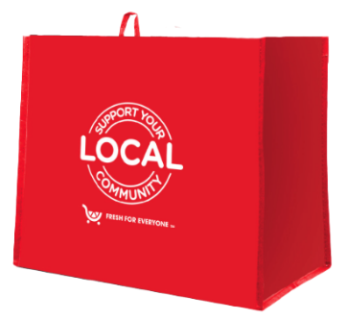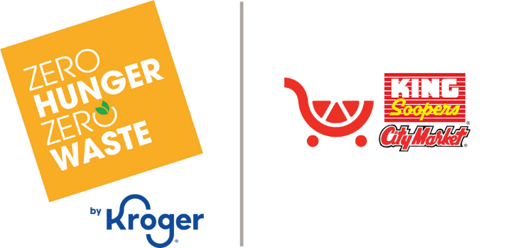

king soopers city market *fight* *hunger* bag program

Fact Sheet

Congratulations on your organization’s selection in the King Soopers City Market *Fight Hunger* bag program!

**Not sure how to start talking about the program? We’re here to help!** We’ve brought together key facts and talking points from across the program website compiled in one place. Below you will find information you can use to discuss this program with your board, staff, and supporters:

1. The King Soopers City Market *Fight Hunger* bag program has been operating since December 1, 2023.
2. Since inception, the program has donated $404,572 to 351 hunger relief organizations and sold 404,572 reusable bags.*
3. King Soopers and City Market operate 155 stores combined across Colorado, Utah, and Wyoming that participate in the program.
4. Designed in alignment with the King Soopers City Market Zero Hunger | Zero Waste initiative, the Fight Hunger bag program makes it easy for shoppers to impact local hunger relief efforts and the environment by simply purchasing a durable, reusable bag. A portion of each purchase goes to a local hunger relief organization.
5. Every other month, the Store Leadership Team at each King Soopers and City Market location chooses a local hunger relief organization to be the two-month-long beneficiary of the *Fight Hunger* bag program. Different nonprofits are selected every

two months to ensure the many organizations making a difference in our local communities can be supported by this program. The name of the organization is displayed on the reusable bag rack during their benefiting period.

1. Generally, the hunger relief organizations selected by a specific store are within a 10-mile radius of that store location. It’s important to note that this program benefits each store’s regional shopping area.
2. From time to time, the King Soopers City Market Community Relations Team may select the benefiting hunger relief organizations in support of a special initiative, such as the Feeding America Holiday Campaign and Earth Day.
3. Each bag costs $2.50, with $1 of that purchase going to support a benefiting hunger relief organization in your community.
4. Hunger relief organizations meeting the [**program's qualifications**](https://kingsooperscitymarket.2givelocal.com/submit-your-organization/) are submitted to our database of thoroughly researched organizations within the vicinity of each store location
5. A list of hunger relief organizations that have benefited from the *Fight Hunger* bag program can be found [**here**](https://kingsooperscitymarket.2givelocal.com/community-impact-by-non-profit/) on the program website and is organized alphabetically.
6. The bags are made from 95% recycled materials from either nonwoven or woven polypropylene. They are manufactured in Vietnam in factories that follow the strictest guidelines for employment and production standards.

*\*As of 5.8.25. These statistics are updated regularly on the program website and can be found* [***here***](https://kingsooperscitymarket.2givelocal.com/program/fight-hunger-bag/)*. You will want to use the most recent stats available at the time of your selection.*

*Published 5.12.25*

ED3024