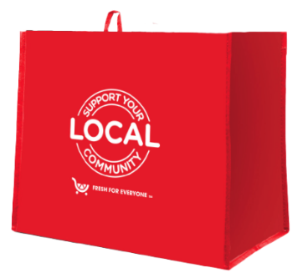

Launch Day Email

& Social Post

**SUBJECT:** Launch day for the King Soopers *Fight Hunger* bag program partnership!

**PREVIEW TEXT:** Our partnership with the King Soopers *Fight Hunger* bag program starts today.

Good morning,

Today is the launch day for our King Soopers *Fight Hunger* bag program partnership! Throughout [*month 1* and *month 2*], when you purchase a reusable *Fight Hunger* bag for $2.50 at the King Soopers located at [*address of selected store(s)*], $1 will be donated to [*name of organization*].

During this two-month partnership, our goal is to sell [*goal of bags bought, e.g., 200*] bags, which is equivalent to $[*insert donation equivalent, e.g., $200*] raised. We are confident that with the help of our dedicated supporters we can reach this goal.

To make the most of this opportunity, we strongly encourage you to share this news with your friends and family. Make sure everyone knows to look out for *Fight Hunger* bags on display racks in our selected store(s) this [*month 1* and *month 2*]!

Thank you for your support!

Best,

[*Signature*]



Share With Your Followers

**Today, we start benefiting from the King Soopers *Fight Hunger* bag program! This [*month 1* and *month* 2], our organization will receive a $1 donation for every $2.50 reusable *Fight Hunger* bag purchased at the King Soopers located at [*store* *address(es)*].**