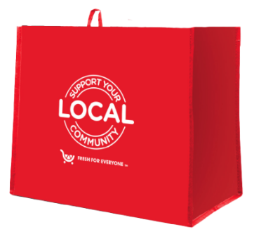

Announcement Email

& Social Post

**SUBJECT LINE:** We’ve been selected to partner with the King Soopers *Fight Hunger* bag program!

**PREVIEW TEXT:** For all of [*month 1* and *month 2*], every *Fight Hunger* bag purchased at our selected King Soopers location will send us a $1 donation.

Dear [*Staff/Board/Volunteers/Supporters*],

We are excited to share that King Soopers selected [*organization*] to benefit from the *Fight Hunger* bag program throughout [*month 1* and *month 2*]. Designed in alignment with King Soopers’ Zero Hunger | Zero Waste initiative, the *Fight Hunger* bag program makes it easy for shoppers to support local hunger relief organizations by simply purchasing a reusable *Fight Hunger* bag!

For the months of [*month 1* and *month 2*], every time a $2.50 reusable *Fight Hunger* bag is purchased at the King Soopers located at [*address of selected store(s)*], $1 will be donated to [*name of* *organization*]. We are thrilled to have this opportunity to broaden awareness of our mission and raise donations for our cause.

Let’s get started! Share the news with your friends and family. Call, send emails, and post on social media. The more people who purchase the *Fight Hunger* bag in [*month 1* and *month 2*], the greater the donation we will receive from King Soopers!

Best,

[*Signature*]



Share With Your Followers

**We’re excited that the Store Leadership Team at King Soopers selected our organization to benefit from the *Fight Hunger* bag program! Throughout [*month 1* and *month 2*], our organization will receive a $1 donation for every $2.50 reusable *Fight Hunger* bag purchased at the King Soopers located at [*address of selected store(s)*].**