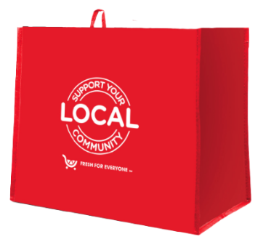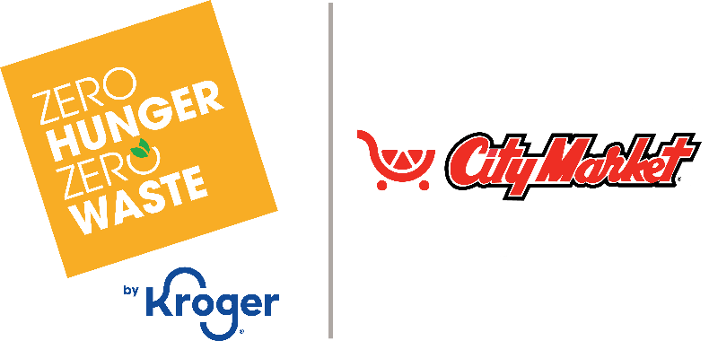

Thank Your Supporters Email & Social Post

**SUBJECT:** We appreciate your support!

**PREVIEW TEXT:** Thank you for participating in the City Market *Fight Hunger* bag program.

Good morning,

We are excited to announce that [*name of organization*] will receive $[*donation amount*] in donations from our partnership with the City Market *Fight Hunger* bag program during [*month 1* and *month 2*].

Thank you for your participation and support during our benefiting months of the City Market *Fight Hunger* bag program. Whether you bought a bag or helped spread the word, we couldn’t have done this without you!

The money we receive from City Market will help us to [*share what you’ll do with the donations*]. Thank you again for making this a fun and successful experience for [*name of the organization*].

Best,

[*Signature*]



Share With Your Followers

**Thank you for your support! We are happy to announce that we will receive $[*donation amount*] from our City Market *Fight Hunger* bag program partnership. Your support helps us continue to make a difference in our community!**