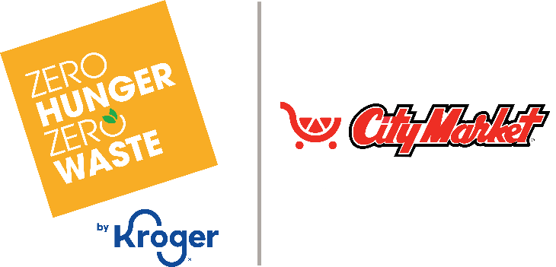

**Month 2 Launch Email & Social Post**

**SUBJECT LINE:** Our second month of the City Market *Fight Hunger* bag program partnership starts today!

**PREVIEW TEXT:** Throughout all of [*month 2*], our organization will continue to receive a $1 donation for every *Fight Hunger* bag purchased at our selected City Market location(s).

Dear [*Staff/Board/Volunteers/Supporters*],

The second month of our partnership with the City Market *Fight Hunger* bag program has officially begun! During [*month* 2], our organization will continue to receive a $1 donation for every $2.50 reusable *Fight Hunger* bag purchased at the City Market(s) located at [*address of selected store(s)*].

Let’s keep spreading the word! Make sure your friends and family know that supporting [*name of organization*] this month is as easy as buying a reusable *Fight Hunger* bag at our selected City Market(s). The more people who know to purchase a *Fight Hunger* bag in [*month 2*] to support our organization, the greater our donation from City Market will be.

Thank you for helping us make the most of this opportunity!

Best,

[*Signature*]



Share With Your Followers

**We’re starting our second month of partnership with the City Market *Fight Hunger* bag program! Throughout all of [*month 2*], our organization will continue to receive a $1 donation for every $2.50 reusable *Fight Hunger* bag purchased at the City Market(s) located at [*address of selected store(s)*].**